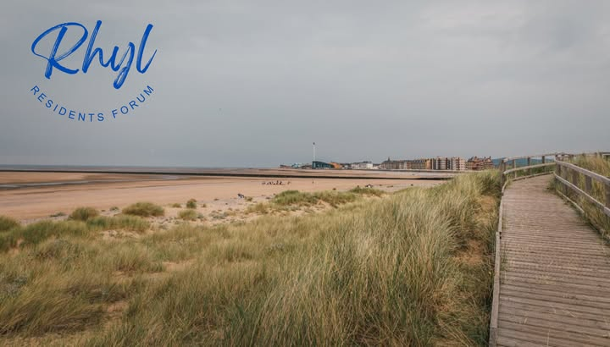

Meeting Notes – 12/02/2026

Introductions & Forum Structure
To start the meeting, Shane thanked everyone for attending and asked for everyone to introduce themselves, everyone gave a brief introduction.
Shane provided an overview of the vision for a forum and explained that initially we are trying to explore whether attendees and those we have spoken to online and in person would prefer a more formal structure (e.g. constitution and specific roles such as a chair, treasurer etc) or a more informal approach.
This was revisited at the end of the meeting. Emma suggested beginning with an informal structure, with the option of moving to a more formal approach later if appropriate. This approach seems to be at this time to most favoured option, which would mean that at any time it could be raised again and formalised.
It was highlighted that “residents” deserve a strong voice in both influencing what happens for the future in Rhyl alongside the ability to raise concerns and have a channel to make small changes “quick wins” on things that are important to them. Established groups like Brighter Futures have these opportunities, but are concerned that single residents do not, and as such are trying to back the forum to begin to address that unfair balance.
Shane explain that we have been collecting thoughts and ideas - priorities from local people in person, online and at a previous meeting to add to what we hear today.

To date there are a large number of “themes” that people have raised, all of these are important and have been collected into a list (a copy of which is attached below).
The 3 most common theme so far have been:

- Influencing and communications with councils
- Cleaning and Greening our Streets
- Community Events

Pride in Place
Shane provided an overview of Brighter Futures experience to date with the Neighbourhood board and his reservations around it’s potential to become the community-led programme its designed to be. He explain briefly the process on his engagement to date and frustration around the way Denbighshire had run the initial stages.

Events Arena
The Events Arena was discussed throughout the meeting. Brian mentioned that with a new budget being implemented and a new CEO in post, it may be an ideal time to raise questions again about community access and use of the space.
There was much feeling that its such a shame the asset isn’t used and that when people and groups try to use it for community events they are often ignored or refused.

Discussion took place about ways the arena could be used, and how to add additional “useability” to it such as it having a cover.

Justin mentioned that alongside the arena “the children village” was a project that was never actually finished, and that originally the site was to have a large play area installed. There was a general feeling it would have been interesting to know more about that and how it would have looked.

Litter Picking
An update was provided regarding the Postcode Gardener, who is currently conducting weekly litter picks. A related flyer was distributed to all attendees.
Brian noted that new fly-tipping enforcement measures are likely to be introduced.
It was mentioned that DCC street scene work hard but have limited resources, however if we are able to link town council, residents, street scene, brighter futures and other organisations we could try to implement a future street cleaning programme, placing skips in street for residents to bring out rubbish, and use that as a way to also talk to local people rather than expecting them to come to meetings, a side discussion around engaging local people in different ways than normal meetings seemed to suggest this could be a better way of reaching more people while solving a current issue that effects a lot of people. There was some additional discussion about “how are streets picked” but no answer to that was reached.

A-Team
Tim and Penny explained the role of the A-Team and how community groups can highlight areas where support is required. This led to a discussion about the bookmakers’ building wall at the entrance to Rhyl from the Blue Bridge, including whether the A-Team could assist with painting and graffiti removal.
Yvonne raised the issue of the planters being removed from the entrance gate and asked whether this was a permanent change or seasonal removal.

Marine Lake
Justin clarified that it is a misconception that DCC benefits from Marine Lake car park charges; the funds are ring-fenced and reinvested into Marine Lake. Vicky noted that this information should be communicated more widely.
Brian asked whether the Marine Lake Forum was still active. Justin confirmed that it is and suggested linking up with the forum.
Penny provided an overview of the Marine Lake allotment project. The space is intended for community use and will be accessible and secure. It will support wildlife, vegetable growing and workshop sessions. The project is in partnership with the council, which retains ownership, and has positive working relationships with Streetscene and Environmental teams.
Judith mentioned she believes a local resident still uses the area, This is a great opportunity and Penny should try to link with that resident and try to support him in anyway possible, it was highlighted that this should be a space for residents to access and that Brighter futures role should be only to enable that and support local people with resources, tools, tidying etc
Shane suggested Penny liaise with Judith regarding this matter, ensure Judith can influence decisions and that we can reach out to the resident and more residents locally to codesign how the area is used.

Council Meetings & Community Engagement
A question was raised about whether residents can attend town and county council meetings. Brian and Judith confirmed that meetings are open to the public, although it was noted that attendance may not always be encouraged and some parts of meetings are closed.
Shane explained that meeting dates are available on the Rhyl Town Council website and you can watch some Denbighshire meetings online.

Events & Community Activities
Yvonne asked how Prestatyn runs its events; it was confirmed this is organised through their business forum.
Nick asked why the Air Show is not taking place this year, and it was agreed this is probably due to the high costs involved, unfortunately DLL never seem to respond to questions when asked.
It was suggested that Rhyl could adopt a coordinated approach, where multiple groups host events on the same day—like Llandudno’s “extravaganza weekend” model.
Shane mentioned that events have been highlighted in the past, one example was from local residents David and Alison who wanted to run “Rhyl’s heyday” but was not possible due to DLL, things like this could really be great for Rhyl.
Justin mentioned the potential to run events at the Marine Lake, this is an option that should be explored along with other sites such as the arena, botanical gardens and beach. The best option will be to link with the marine lake forum via Justin and explore options and if Brighter Futures can help with sourcing funding for community events.

Council Plans & Wales in Bloom
A discussion took place regarding proposed council investment plans, including the £20 million development, pocket park and High Street improvements.
Shane explained the funding for the pocket park and Highstreet improvements (planting and clock tower developments) are separate to the £20M pride in Place
Penny shared that Rhyl is entering Wales in Bloom for the first time in several years and currently has the second-highest number of participating groups in Wales, with 13 involved. The target for this year is between 25 and 28 groups. Emma suggested contacting and linking with “Friends of the Railway.”

Community Engagement & Next Steps
Nick commented that the forum should aspire to be a serious voice in consultations, plans, developments, etc, relating to Rhyl. Also, in applying for grant funding for activities and projects etc, This must be sustainable with measurable outcomes.
Shane confirmed that the new CEO at DCC, Helen White, will be visiting Rhyl in April, with plans to meet several community groups.
A meeting is booked to also discuss the Wellington Community Centre.
A positive tone was maintained throughout the meeting. As the meeting concluded, Emma asked about next steps. It was agreed that monthly meetings would be beneficial, with the same day and time identified as the most convenient. Shane suggested introducing a “theme” for future meetings to explore specific topics in more detail and in the meantime using email and the online forum to update and communicate with each other.

Proposed Meeting Date
- 12th March 5.30pm – Venue TBC

Actions:
- Penny to follow up regarding the possibility of improving the area with planters and general enhancements.
- Shane to follow up with what can be done about the graffiti on the wall of 188 Wellington Road.
- Tim to follow up with finding out if the planters will return to the entrance gate.
- Tim to contact DCC and ask if information could be communicated more widely about the carparking charges at marine Lake.
- Justin to assist with linking up with the Marine Lake forum and exploring if we can help each other.
- Emma suggested contacting and linking with “Friends of the Railway.” No one has any details for them, Could Emma get contact details?

The 4 Questions

1. What should the resident’s forum do?
2. What Matters to you locally?
3. What would make this forum worth your time?
4. Any other comments, suggestions or feedback

Comments received

Most comments: I agree with the feedback already given.

1. Be the voice of Rhyl people – to represent views to local authority, and services such as police, fire & local health board (BCUB) – working in partnership! Make representations / demands / work in partnership with the above – keep a dialogue open – so we raise issues for our partner organisations, e.g., police to action.

2. Rhyl’s reputation, litter/fly tipping, environmental management, public safety. Decay/regeneration, investment! Community cohesion. Town events. Child Welfare.

3. Meaningful actions – not just moaning – links with local services, etc. So that our voices are heard – e.g., we could request a visit from our MP/MS. Rhyl is still the most deprived area in Wales – nothing has changed in X years. If we could change things

4. Agree that the forum should aspire to be a serious voice in consultations, plans, developments, etc, relating to Rhyl.

